**Create Mysql Database backup**

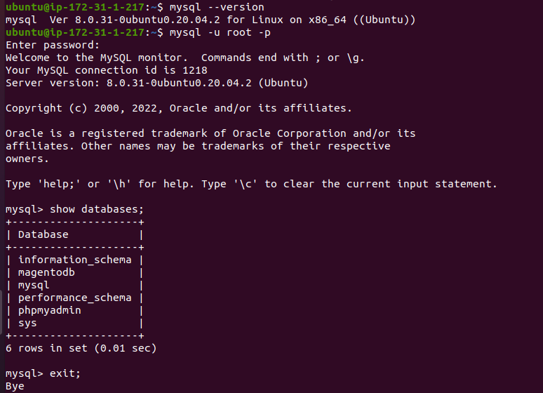

mysql –version

mysql -u root -p

show databases;

mysql -u **$username** -p**password databasename > databasebackupname.sql**



**Restore database**

**SCP**

scp -i webkul.pem ubuntu@43.205.203.34:/home/ubuntu/test .

{copy test file from myEC2 Server to my Localmachine}

**Restore Database to another EC2 Server**

we have to need .pem file for scp

**Step1**: I have Create Backup for magentodbbackup.sql

**Step2**: I will Send magentodbbackup.sql in My Localmachine

scp -i webkul.pem ubuntu@3.110.42.178:/home/ubuntu/magentodbbackup.sql .

magentodbbackup.sql

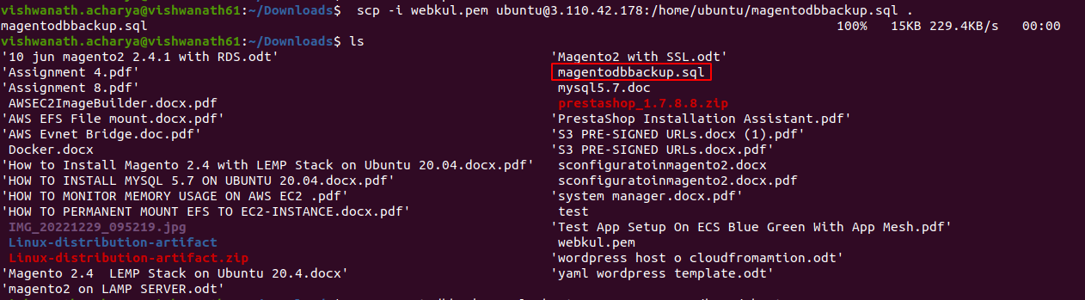

**Step**3: I have to send this magentodbbackup.sql to my New EC2 Server



scp -i webkul.pem magentodbbackup.sql ubuntu@43.205.203.34:/home/ubuntu

magentodbbackup.sql

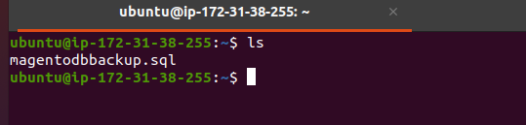New Server

**Direct Create Backup for Mysql database**

sudo mysql -h 3.110.42.178 -u root -ppassword magentodb > backup.sql

ls

**Restore Mysql Database**

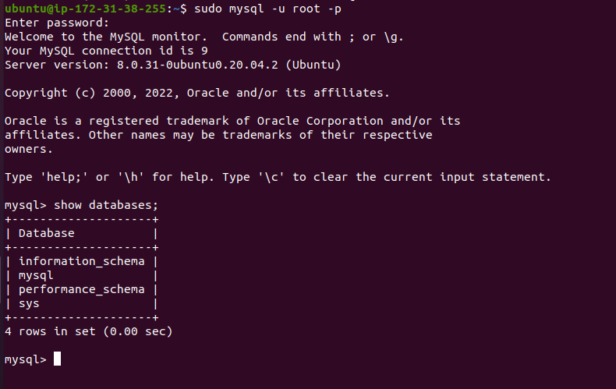

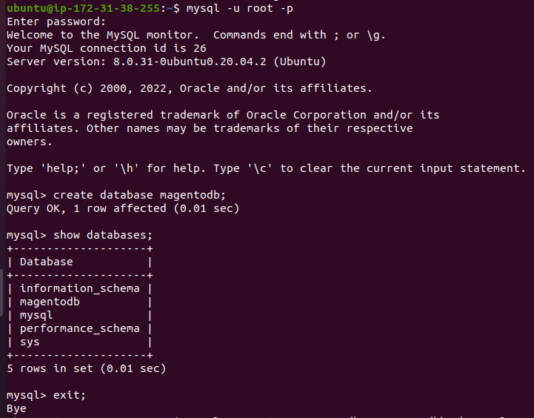



mysql -u root -p password magentodb < magentodbbackup.sql

https://www.tecmint.com/mysql-backup-and-restore-commands-for-database-administration/

https://cyberpanel.net/blog/how-to-backup-and-restore-mysql-database-from-command-line/

=======================================================================

Create **Two** EC2 Instance

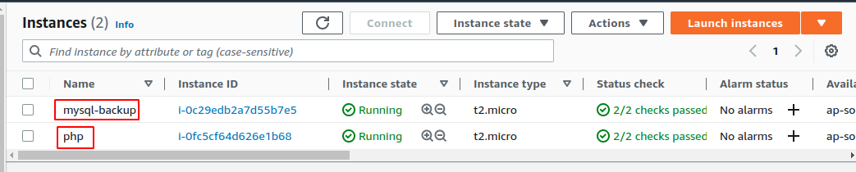

Connect Both Of us Your Local Machine with SSH

Instance Php i have Install Wordpress Server

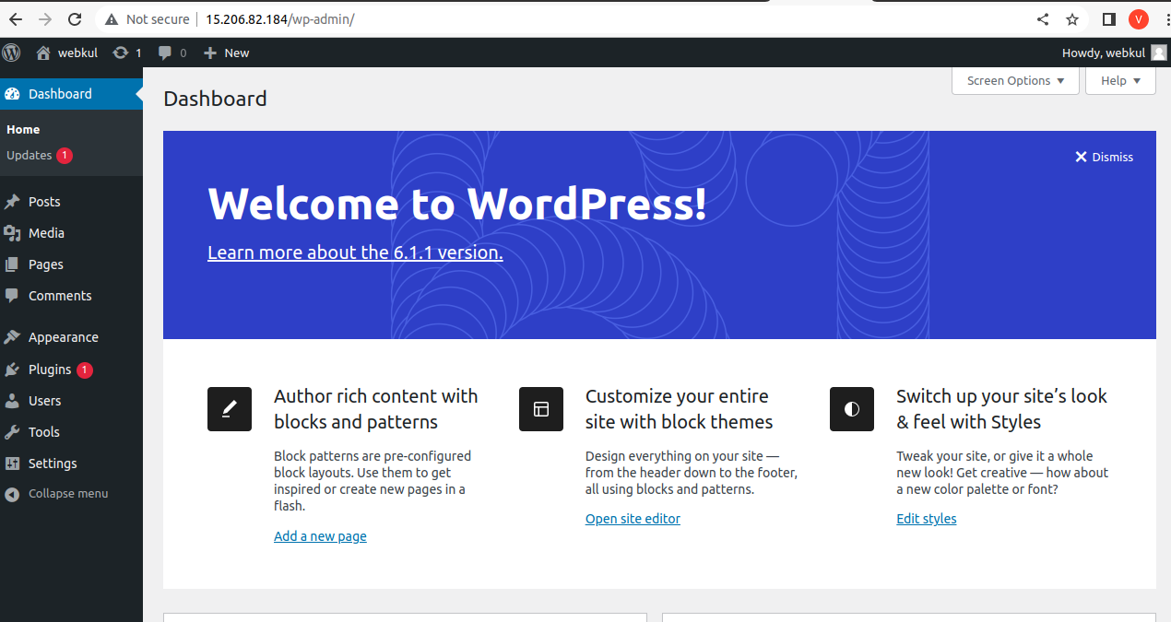

sudo apt-get update

sudo apt install apache2

sudo apt install software-properties-common

sudo apt-add-repository ppa:ondrej/php -y

sudo apt install php8.1 php8.1-mysql -y

sudo apt install mysql-server -y

sudo mysql -u root -p

alter user ‘root’@’localhost’ identified with mysql_native_password by ‘password’;

create database wpdb;

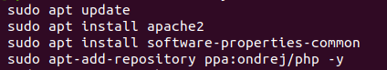



sudo nano /var/www/html/info.php

<?php

phpinfo();

?>

cd /var/www/html

sudo wget -c [http://wordpress.org/latest.tar.gz](http://wordpress.org/latest.atr.gz)

sudo tar -xvzf latest.tar.gz

sudo rm -rf latest.tar.gz

sudo mv wordpress/* .

Sudo mv wp-config-sample.php wp-config.php

sudo nano wp-config.php

{ add database name dbuser name dbpassword }

sudo systemctl restart apache2

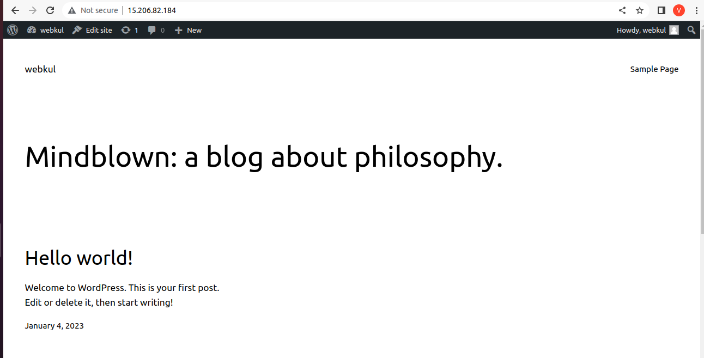

**open Mysql for take backup databse**

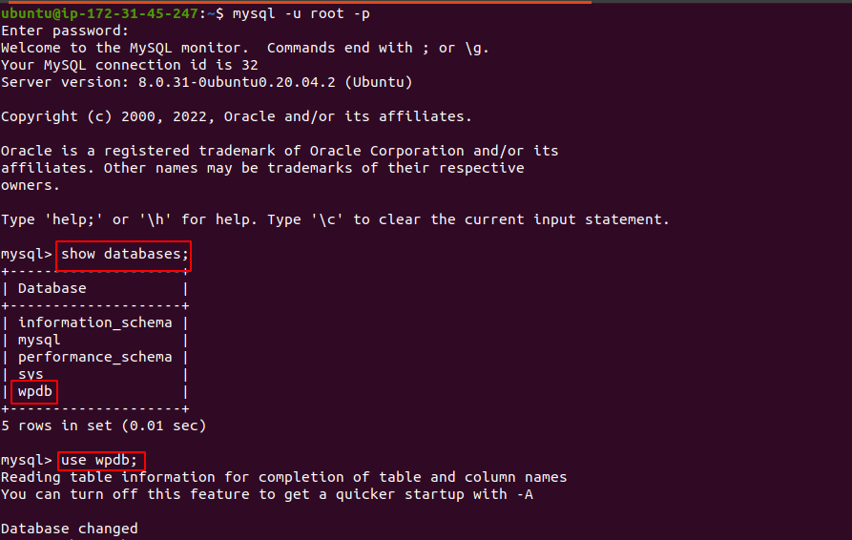

mysql -u root -p

show databases;

use db;

show tables;

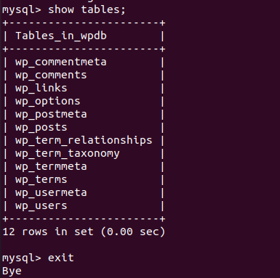

**take backup**

mysqldump -u root -p wpdb > wpdb.sql



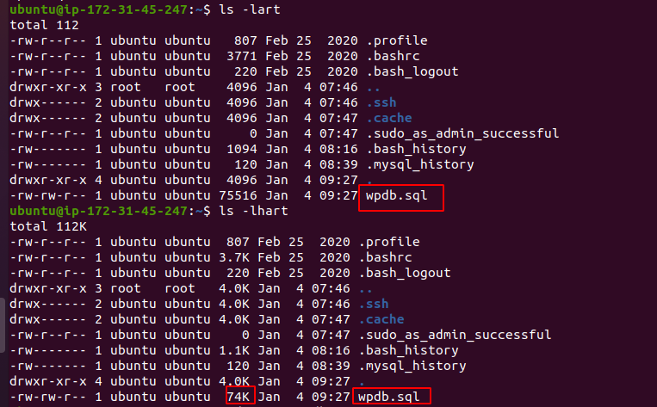



**open Another EC2 Server for Restore Backup**

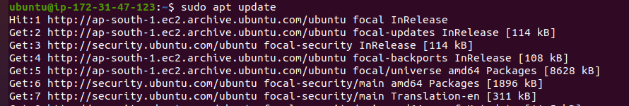

need .pem file for scp





sudo nano webkul.pem

sudo chmod 400 webkul.pem

sudo scp -i webkul.pem [ubuntu@15.206.82.184](mailto:ubuntu@15.206.82.184):/home/ubuntu/wpdb.sql .

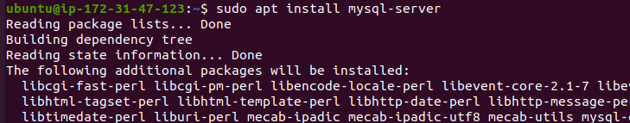

sudo apt install mysql-server -y

sudo mysql -u root -p

alter user ‘root’@’localhost’ identified with mysql_native_password by ‘password’;

create database wpdb;

exit;

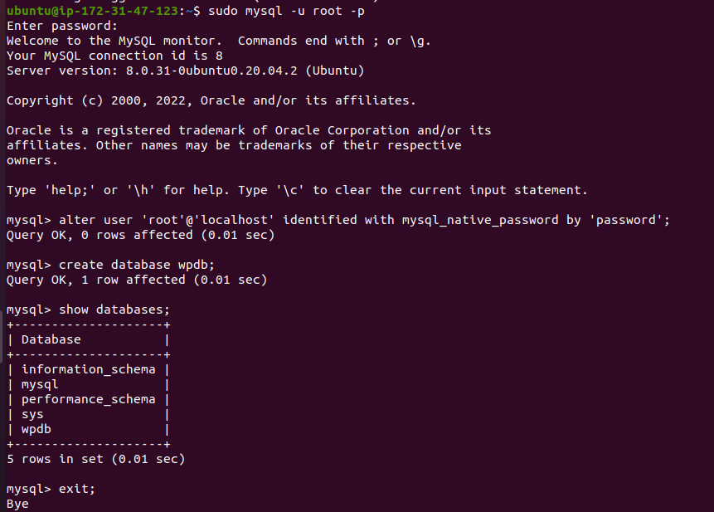

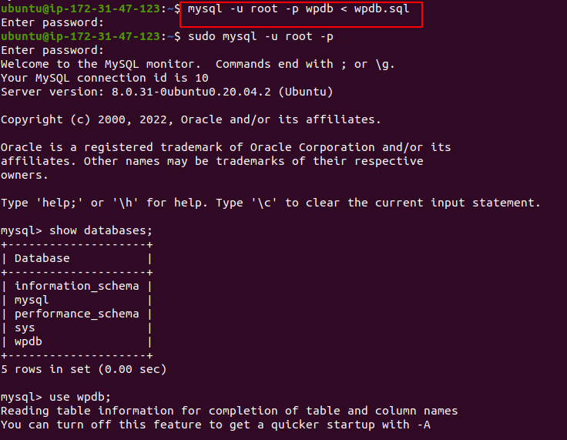mysql -u root -p wpdb < wpdb.sql

mysql -u root -p

show databases;

use wpdb;

